LAB_7 DC motor interfacing with PIC controller

1. Objective:
- To be familiar with PIC Microcontroller
- To be familiar with PIC16F877A Microcontroller internal and external structure and its configuration.
- To know how to control both speed and direction of DC motor.
2. Required Components
Table 1. Components
Qty. | Component Name
1 | PIC16F877A
1 | BreadBoard
1 | DC Motor 12v 1000RPM
5 | Push Buttons
1 | Resistors Kit
1 | Capacitors Kit
1 | Jumper Wires Pack
1 | L293D DC Motor Driver
1 | LM7805 Voltage Regulator (5v)
1 | Crystal Oscillator
1 | PICkit2 or 3 Programmer
2 | 9v Battery or DC Power Supply

3. Introduction
3.1 How A DC Motor Works?
DC Motors are very simple rotary actuators that transform electrical energy into a mechanical rotation at a specific torque. A typical DC motor will have the following features:
- Torque (in kg.cm)
- Rated Rotation Speed (RPM)
- Rated Full-Load current (e.x. 2A)
- Rated No-Load current (e.x. 0.2A)
- Rated voltage for operation (e.x. 12v)
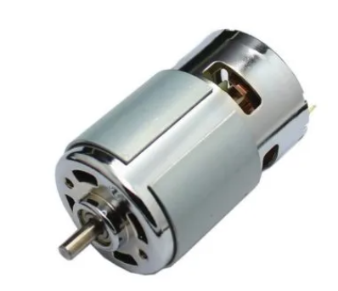
Figure 1. DC motor
Electrical current is passing through coils that are arranged within a fixed magnetic field (Stator). The current generates magnetic fields in the coils. Which in turns causes the coil assembly (Rotor) to rotate, as each coil is pushed away from the like-pole and attracted to the unlike-pole of the stator.
Reversing the direction of current flow in the coil translates to an inversion in the direction of the rotor’s magnetic field. Which in turns applies an inversed torque of each side of the coil resulting in a reverse direction in the rotation.
This is simply how a DC motor is actually working. Now, it’s our mission to control the behavior of such a device as we’ll discuss in the section right below.
3.2. How To Control DC Motors?
Controlling a DC motor involves two different processes. The 1st one is controlling the direction of the motor’s rotation CW & CCW (Clock-Wise & Counter-Clock-Wise). The 2nd one is controlling the speed of rotation. Hereafter, we’ll discuss each of these processes in more detail.
Direction Control
To control the direction of a DC motor, you need to reverse the polarity of the input power source. In fact, polarity-reversal circuitry has many implications and it can go really complex and tricky. This sort of driver circuitry is called to be H-Bridge. it’s an H-shaped circuitry in which the DC motor is hooked through Switches/Transistors between the power rails ( V_{M} & Ground ). Altering the activated switches reverses the polarity of the voltage (V_{M}) applied to the DC Motor. Hence, the rotation direction is reversed.
Actually, a real-world H-bridge will not have ON/OFF switches. Instead, there will be 4-Transistors which are basically electronic switches doing the job of reversing the polarity of the motor supply voltage. Designing and building a fully-functioning H-Bridge circuit is beyond the intent of this tutorial. However, we’ll discuss a couple of ways to get polarity-reversal H-Bridge solutions on the cheap and so easily with the least overhead.

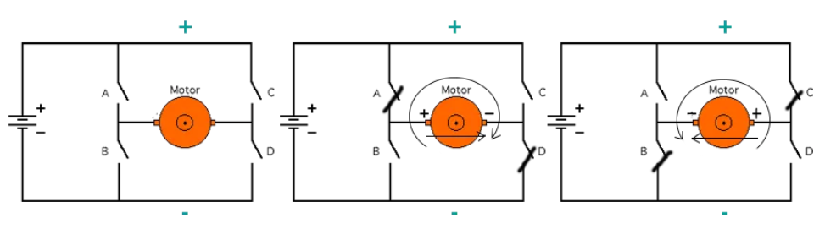
Figure 2. Direction control
Actually, a real-world H-bridge will not have ON/OFF switches. Instead, there will be 4-Transistors which are basically electronic switches doing the job of reversing the polarity of the motor supply voltage. Designing and building a fully-functioning H-Bridge circuit is beyond the intent of this tutorial. However, we’ll discuss a couple of ways to get polarity-reversal H-Bridge solutions on the cheap and so easily with the least overhead.
L293D Motor Driver IC
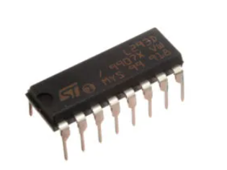
Figure 3. L293D IC
This integrated circuit (IC) is a 2-channel full H-Bridge motor driver. That is capable of driving two distinct DC motors. It’s the easiest way to go around building a whole H-Bridge driver from scratch. It comes in a DIP package which fits nicely on a typical breadboard. The L293D provides an easy wire-up interface with some decent features as follows:
- Motor Channels: 2
- Output Current Per Channel: 0.6A
- Output Peak Current (Non-Continuous): 1.2A
- Supply Voltage: up to 36v
- Switching Frequency: up to 5kHz
- Thermal Shutdown (Overheat Protection)

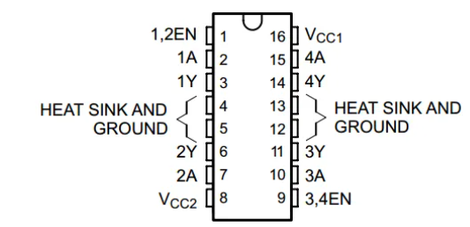
Figure 3. L293D IC pin

Speed Control
Controlling the speed of a DC motor’s rotation (Permanent Magnet Motors) is basically achieved by a couple of ways as shown below:
- Variable Supply Voltage
- Using PWM-Controlled Gate
Variable Supply Voltage: can be achieved using voltage regulation circuitries. However. there are too many limitations and drawbacks to such a method. But theoretically, it just works and does the job! Varying the supply voltage will definitely control the motor’s speed accordingly.

Using PWM-Controlled Gate: is the most common technique for digitally-controlled systems. It’s basically done be isolating one of the power source rails from the H-Bridge circuitry using a transistor. Hence, creating an open circuit with the (Ground or VM+). In this way, activating the Control Gate (the transistor) will cause the H-Bridge to be powered-up then the motor will start rotating. Regardless of the direction of rotations, activating the control gate with a PWM signal will somehow control the average voltage being delivered from th The gate transistor in this setting is controlling whether the negative power rail is connected to the H-bridge circuit or not. By turning this transistor ON/OFF using a PWM signal, we’ll be seemingly controlling the average voltage being delivered to the DC Motor. e supply to the motor through the control transistor. A simplified diagram is shown right below
The gate transistor in this setting is controlling whether the negative power rail is connected to the H-bridge circuit or not. By turning this transistor ON/OFF using a PWM signal, we’ll be seemingly controlling the average voltage being delivered to the DC Motor.
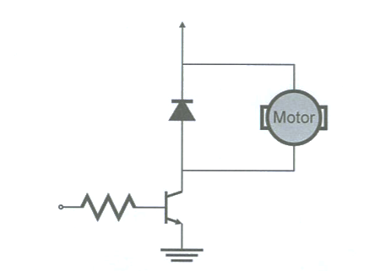
Figure 4. Motor control
4. Experiment_ DC Motor Speed Control – LAB
4.1 Coding:
- Open the MPLAB IDE and create a new project.
- Define the IO pins used for controlling (choosing) the desired speed levels and direction reversal.
- Output pins in order to send the direction control logic signal to the motor driver. Let’s use a couple of PORTD pins for this function.
- Configure the module to operate in PWM mode, output a PWM signal with a 2kHz signal.
- Write the main loop (routine) of the system.
- Which is basically polling the Buttons and apply the respective action of varying the DC (duty cycle) or reversing the direction of rotation
4.2 Simulation:
- Using Proteus with PIC18 and 5 Pull-Down Push Buttons to the pins RB0-RB4. Connect the L293D IC, fetch hex file and run the simulation.

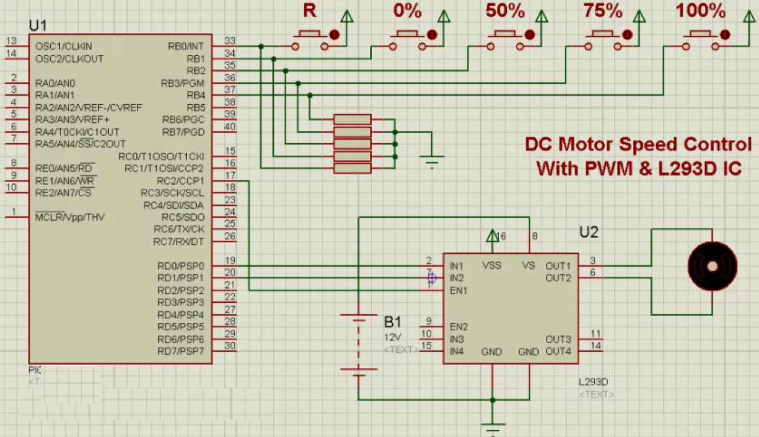

Figure 5. Circuit diagram

4.3. Prototyping
- Prototyping this project involves connecting a relatively larger power supply (12v).
- Follow the schematic diagrams
5. Homework
Write an C program for controlling multiple motors with PWM and BS interface.
Name: Student Code: Class: Lab:
- Circuit
- Algorithm flowchart
- Code and explanation
- Summary

